Student Guide to Google Drive

- First, you must create a gmail account. If you have a personal account, we strongly suggest that you add a new school account, so you can separate your personal and academic emails.
- Next, sign into your account, and go to the Google Drive folder address your teacher has provided.
- Now, you are ready to create a folder. Click on the “NEW” icon in the upper left-hand corner, scroll down to “folder,” click, and name your folder.
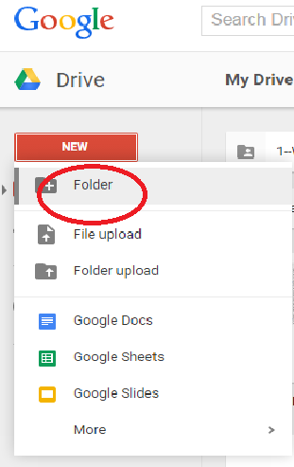
- Now, you are ready to create a document. Click on the “NEW” icon, scroll down, and click “Google Docs.” Click the “Share” icon, and name your document.

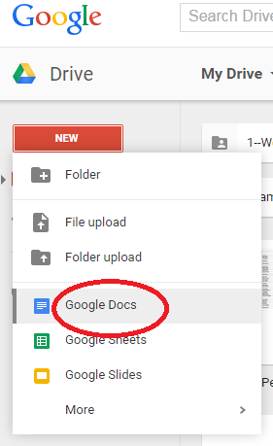

Voila! You are all set! The best news is that your work saves in real-time! You have access to your document anywhere there is internet. You can collaborate with other students, and the drive will keep a log of your activity, allowing you to recover work, easily!

Google Drive: Adjusting Share Settings

Many students,teachers, and parents are apprehensive about using Google Drive, because it can be tricky to control and support student privacy. However, Google Drive offers a variety of options that allow teachers and/or students to share and restrict access to documents and folders to the degree that they are comfortable. This allows teachers and students to collaborate in a safe and protected environment. See the list of the share setting options and their descriptions below.

Who has access?
- Public on web- This option allows anyone on the internet to access materials. We do not suggest that teachers or students use this option for assignments, as it is the least restrictive privacy setting.

- Anyone with the link- This option allows teachers and students to share folders, documents, and presentations through the associated link. This is a great option for teachers who would like students to access a specific folder through his/her blog. However, students will rarely use this option, as it is only minimally restrictive.

- Specific people- This option allows only specific people, who are invited via their gmail addresses, to have access to materials on Google Drive. This is a great option for students who would like only the teacher and specific peers to see their work. This is also a great option for teacher who would like to collaborate with their colleagues. This is the safest, most restrictive, and most widely used share setting.
What can people with access do in my folder, document, or presentation?
- Can edit- This option allows people with access to a folder to make changes to shared materials. This option is ideal for group work/projects and teacher collaboration. However, students who are working on individual long-term assignments should avoid this setting. This prevents others from tampering with shared materials. Don’t worry! If this happens, there are ways to find out who tampered with the materials and restore original content.

- Can comment- This option allows people who have access to documents to make comments about the material, without changing the content. This option is valuable for long-term writing assignments, as it easily allows for teacher and peer feedback.

- Can view- This option allows for people with access to a folder, document, or presentation to view the material. However, the viewer will not have an option to interact with the material. This option is ideal for teachers to use when posting notes and rubrics. This is also a great option for students to use when presenting projects.

How do I adjust my share settings?
- Right click on the desired folder, document, or presentation, and click share.
- Press “Advanced” in the lower right-hand corner of the box.

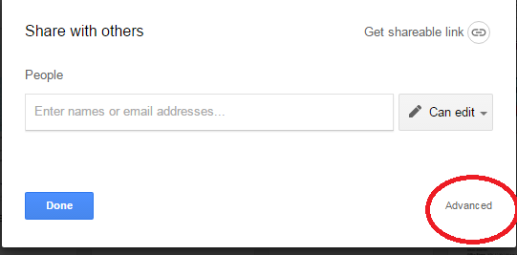

- Select the share setting option that fits your needs.
- Public on the web – limited privacy; not advised for school use
- Anyone with the link- great for teachers who want to share assignments or folders on their blogs; not advised for private student work
- Specific people- safest option; people are added to folders through their gmail addresses

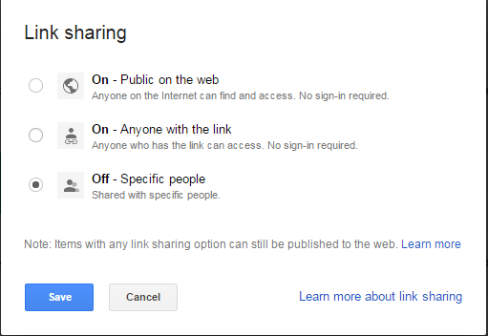

- Once you have chosen your share setting option, click save. Make sure to adjust your editing permission, and you are all set!
